2 February 2015 Probation Pay Bulletin No. 5

96% of UNISON Members Vote to Reject 0% Pay Offer and Take Industrial Action
96% of UNISON members taking part in our recent pay consultation ballot have voted to reject the shameful 0% pay offer from NOMS and indicated their willingness to take industrial action to seek to improve it.
This is an overwhelming vote of no confidence in the way that NOMS has handled the 2014 pay negotiations for probation staff. UNISON members are sick to the back teeth with the disgraceful way in which they have been treated.
NOMS Thinks You’re Worth Nothing!
It’s no surprise that members have voted to reject an offer that is worth nothing:
- The decision to deny probation staff a 1% pay rise for 2014 must have been a political decision, by MOJ ministers, because we got a 1% pay rise in 2013 and nothing has changed in government pay policy since 2013

- If ministers signed off a 1% pay rise for you last year, why have they refused to do so again this year?

- If, as we suspect, ministers did make this decision it is an affront to all probation staff who have been put through the mill over the last 12 months to deliver the government’s misguided Transforming Rehabilitation programme

- 0% is a slap in the face at the very time when NOMS should be supporting its staff through the trauma of TR

- It’s nothing short of a disgrace

What Happens Next?
UNISON is now in discussion with our sister unions Napo and GMB in relation to our consultative ballot result. Napo’s National Executive Committee meets on 9 February and will be considering its position on a potential pay dispute at this meeting.
Once we know the position of our sister unions, our National Probation Committee can make an application to UNISON’s Industrial Action Committee for authority to commence a formal industrial action ballot of all our probation members. UNISON is already making the necessary preparations to conduct this ballot, which will involve all UNISON probation members receiving a secret ballot at their home address.
The three probation unions are now seeking an urgent meeting with Michael Spurr, the NOMS Chief Executive, to see if common sense can be restored and the offer we all expected to receive this year be re-instated.
Why It Is Important That We Make A Stand On Pay
- Unless we challenge the NOMS approach to pay this year, the same is likely to happen again in the future.

- Can you afford not to get a pay rise next year as well?

- UNISON believes that the way you are being treated this year is the start of an attack on the terms and conditions which you brought with you into the NPS/CRC from your Probation Trust

- If we do not oppose this attack on your terms and conditions now, NPS and the CRCs will see this as a green light to worsen other terms and conditions.
The fantastic result to our pay consultation ballot shows that UNISON members are ready to stand up for their rights at work. If we have to ballot you for industrial action, we are confident that members in both the NPS and the CRCs will respond positively to the call.
JOIN UNISON
Decent pay and conditions do not happen by accident and they cannot be taken for granted. The terms and conditions which you brought with you into the NPS, or a CRC, in June last year are worth defending; they are the result of many years of patient negotiation.
If you are not already a member of a trade union, UNISON encourages you to join us now to help defend your pay and conditions going into a very uncertain future.
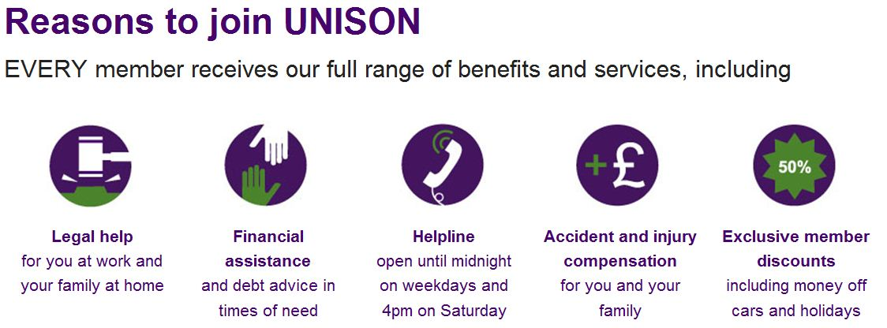Call FREE on 0800 171 2193 or visit www.joinunison.org

