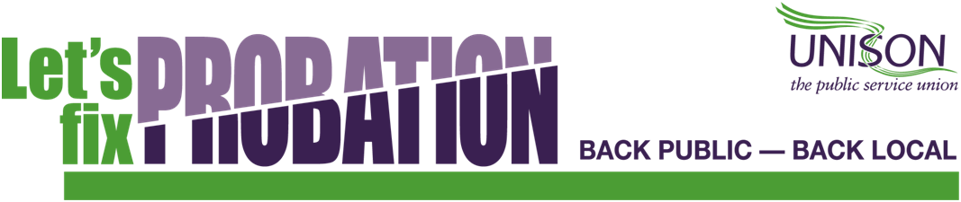

9 May 2019 Issue 04/19

MOJ TEST WHETHER SPLIT IN SERVICE UNDER TR SHOULD CARRY ON

Following the devastating criticisms of end of May. UNISON understands that the Transforming Rehabilitation set out in the MOJ is discussing a range of alternative National Audit Office report published on 1 options for the future of probation in March 2019 and the Chief Inspector of Pro- England, including the option already con-bation’s Annual Report published on 29 firmed for Wales, which is to transfer all

March 2019, the Ministry of Justice is now consulting CRC owners on the pros and cons of different models for probation service delivery in the future. This is not surprising given the fact that TR has failed so badly.

This suggests that the MOJ is testing whether the original split in the service under TR should be maintained before announcing its final proposals for the future
of probation, which are expected before the
offender management work from the Wales CRC to NPS Wales.

UNISON is aware that some CRC owners have passed on information about the discus-sions which they are having with the MOJ to their staff and are making the case for continued private sector involvement in probation, as we might expect. UNISON is continuing to press MOJ Ministers and offi-
cials to return probation to the public sector.

UNISON “LET‟S FIX PROBATION” CAMPAIGN
UNISON campaigned against TR and has of Local Probation Services under local

argued for the return of probation to public
sector ownership and control since the CRCs
control and management. We will continue to
make this case. Probation will only function

were privatised in February 2015. This is properly again as a truly unified service.

the right thing to do and is the only outcome which will put probation back on its feet again.

Returning offender management to the public sector, as part of the NPS, would be a step in the right direction, but UNISON’s ‘Let’s Fix Probation’ campaign argues that all probation work should be brought back
under public ownership via the re-creation

In Wales we are working with the NPS to return offender management from the Wales CRC into NPS Wales, as has already been agreed by the MOJ for Wales, but also arguing that all CRC work should return to public control, including unpaid work and
programmes/interventions.

Page 2

JOIN UNISON

UNISON expects that the government will make a statement on its final decision on the future of probation by the end of May. We hope that there will be positive news, but expect that the work to fix probation will have to continue whatever the announcement.

Join UNISON now to add your voice to our „Let‟s Fix Probation‟ Campaign and pro-tect your job in the uncertain times for probation going forward.

CALL FREE ON 0800 171 2193 OR VISIT WWW.JOINUNISON.ORG

