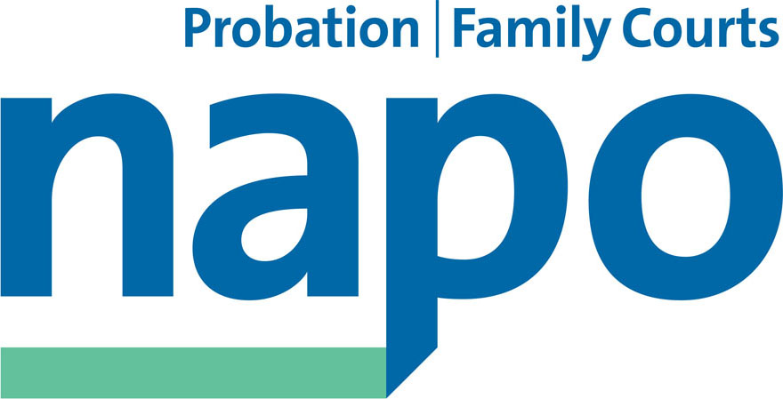

**JTU 01-13**

10th May 2013

Mark Ormerod

Employers Side Secretary

National Negotiating Council / SCOG

Probation Association

29 Great Peter Street

London SW1P 3LW

Dear Mark,

**Transforming Rehabilitation: A Strategy for Reform**

We write as the three Probation trade unions in relation to the above, following the publication of the Government’s response to the ‘Transforming Rehabilitation’ consultation exercise, released yesterday.

We are struck by the complete absence of any reference in the Strategy to the role of the Probation negotiating machineries in handling the controversial and complex employee relations issues which will undoubtedly arise from the Government’s reform agenda.

As we made clear to the Probation Minister Jeremy Wright, at our meeting with him on 9 May, we expect these employee relations issues to be handled exclusively by the Probation National Negotiating Council and the Standing Committee for Chief Officer Grades.

At page 34 of the Strategy document we find reference to the following: ‘Early testing of service models and HR plan with Probation Trusts’ (Summer 2013), ‘Restructure Probation Trusts under existing governance’ (Spring 2014) and ‘Implement new Public Probation Service’ (Autumn 2014).

Given that we have already reached ‘Summer 2013’, we have to express our serious concern that the NNC and SCCOG may already have been overlooked by NOMS officials in their implementation plans; this would clearly be unacceptable.

In light of our concerns we seek the following:

* an urgent meeting at Joint Secretarial level for both machineries to discuss how the NNC and SCCOG will take ownership of the HR and employee relations issues arising from the Strategy
* advice from the NNC and SCCOG Joint Secretaries to the effect that Trusts should await guidance from the national negotiating bodies before any work commences on local discussion of the employee relations work streams set out in the Strategy

We look forward to hearing from you at the earliest opportunity.

Yours sincerely

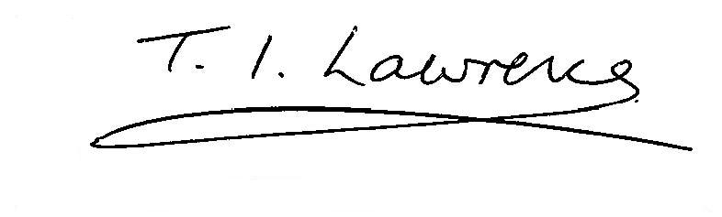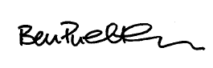

Ian Lawrence Ben Priestley David Walton

Acting General Secretary National Officer National Secretary

Napo UNISON GMB/SCOOP

Cc Jeremy Wright, Probation Minister

Michael Spurr, CEO NOMS